GTASS- Design Documentation

# Overall Design Pattern

For this project, we decided to implement the Model-View-Controller design pattern that is commonly used in web development. This pattern encourages code modularity and maximizes the potential for the website to be expanded with further functionality. Modification to the baselines are also simplified because of the clean and intuitive organization of source files. The diagram below serves as a visual for this model:

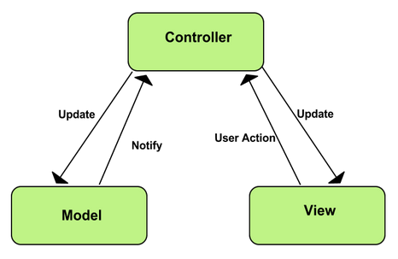

Figure : Standard MVC Pattern Implementation ([Source](https://developer.chrome.com/apps/app_frameworks))

# The Database

The database schema was architected based closely on the set of requirements laid out by the project description. The primary influence on its design arose from the goal to minimize data redundancy and the number of functional dependencies within tables. For example, there are two forms on the website that share several attributes: the Nomination form and the Nominee Information form. Originally, we were storing the shared attributes independently in both tables. However, we later realized that we could exclude those attributes from the Nominee Information table and create foreign key that references the Nomination form table. As a result of decisions like this, we believe our relational schema is well-defined and minimal. The Entity-Relationship diagram for our schema can be found on the next page.



Figure : ER Diagram for GTASS Schema

# Use Cases



The GTASS has 4 types of Users: Nominees, Nominators, System Admin, and GC Member. The way that it has been set up allows for all of the users except for the Nominees to log in. They all interact with one another via input forms, where they can comment, score, approve or just review given information. The Admin is in charge of creating sessions and adding Nominators and GC Members. The GC Members are in charge of scoring the students based on the information they turned in. The Nominators have the ability of adding Nominees, and then verifying the information the students provided. The Nominees fill out a form with accurate information that will be revised by the Nominators, and eventually scored by GC Members.

# Activity Diagrams

The following diagrams illustrate the possible actions that can be taken by users of the system.

## Admin and Session Activity



The System Administrator manages the creation and closing of the session. This includes creating user accounts for the session. GC accounts are created during session creation because all GC accounts are associated with a single session. This is done to prevent GC members in previous sessions from participating in later sessions (unless new accounts are created for them).

When the Admin closes the session, GC member can no longer add scores and comments to nominees.

## Nominator Activity



The Nominator nominates potential GTA’s and reviews their information forms.

## Nominee Activity



When Nominees are nominated, they receive an email to the link where they will be filling out all the required information. If Nominees has not provided the information or it’s inaccurate, the system will send warnings. The form is then saved to the database, if the deadline has been missed, the system will send a message to the nominee.

## GC Member Activity



As the GC Member logs in to his account, he is taken immediately to the Score Table view. If his session is currently closed, GTASS displays a message. A GC Member can view incomplete Nominations, a GC Member can also score and comment on each Nominee within the Current Session Score Table, within the Score Table view he/she can click on a nominees name and review all the information for that student, and finally he/she can view previous sessions with their respective score tables.